Geometry CP Final Exam Formula Sheet
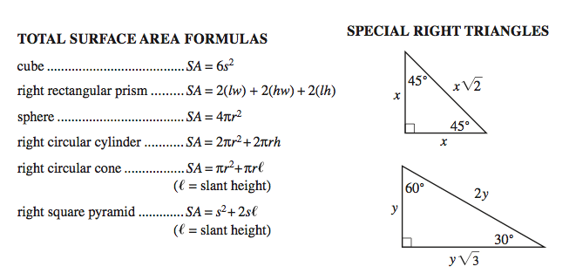
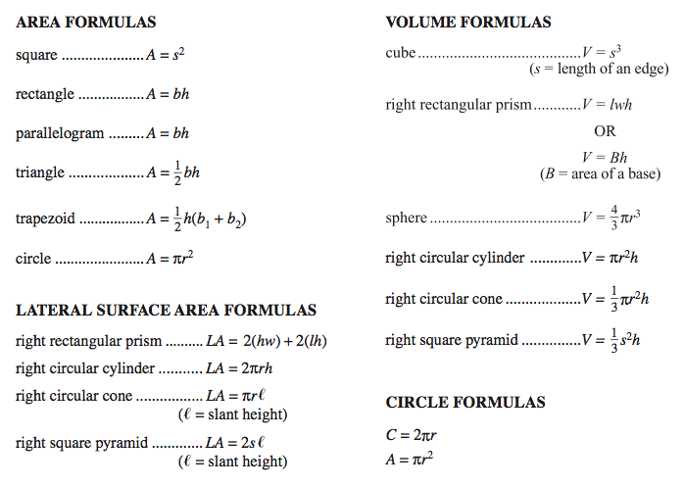

OTHER FORMULAS
Area of a Kite/Rhombus…………$A=\frac{1}{2}d_{1}d_{2}$ Sum of the interior angles of a polygon$=\left(n-2\right)180$
Area of a triangle……………………$A=\frac{1}{2}ab\sin{C}$ Each exterior angle of a regular polygon=$\frac{360}{n}$
Area of a sector ………………..……$A=πr^{2}\frac{x}{360}$ Arc length ………………………..…..$L=2πr\frac{x}{360}$

TOTAL SURFACE AREA FORMULAS VOLUME FORMULAS
Prism/Cylinder………………..$ph+2B$ Prism/Cylinder………………..$Bh$
Pyramid/Cone…………………$\frac{pl}{2}+B$ Pyramid/Cone…………………$\frac{Bh}{3}$

